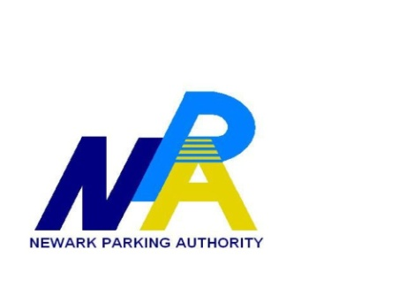

PLEASE TAKE NOTICE that the Meeting of the Board of Commissioners of the Parking Authority of the City of Newark scheduled for October 24th, 2019 at 5:00 is CANCELLED The next meeting is scheduled for THURSDAY November 14th, 2019 at 5:00 PM, at the Authority Offices located at 50 Park Place, Suite 919, Newark, New Jersey. All other meetings remain unchanged.

